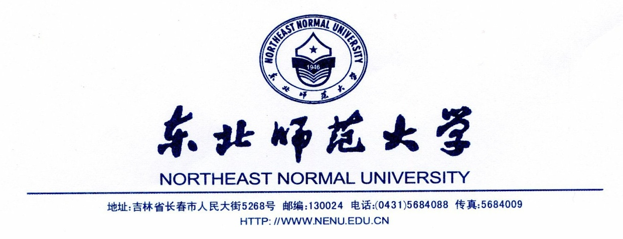

This is to certify that Mr./Ms. , born on , is a/an (lecturer/associate professor / professor/ program officer) of Northeast Normal University. Invited by , Mr./Ms. will visit for international conference/ academic exchange during , 2018 – , 2018 , altogether days.

Northeast Normal University is liable to pay all the cost for Mr./Ms. , including the round-trip international air tickets, accommodations, meals as well as the medical insurance for the whole period of his/her stay in .

We declare that he/she will abide by the local laws during his/her stay in , and will come back to China on time. When the trip is finished, Mr./Ms. will continue his/her job with the same position.

Northeast Normal University

(Seal)

, 2018

